**Sensor Monitoring System Upgrade Recommendation**

Provided by:   
Arthur Bondar

NSCC Applied Energy Research Lab

Document Prepared on:

August 9th, 2017

**Existing system overview**

Current Water Temperature Monitoring system was built as a senior project in spring 2017. Main scope of the system is water tank temperature monitoring. Full system description is at OurNscc/AER Projects/How Water Tank measurements.  
System capabilities:

* Monitor 5 temperature sensors
* Display temperature on LCD screen
* Record data in CSV format

System cost:

|  |  |
| --- | --- |
| Raspberry Pi 3 Model B | Available as a kit for approximately 60 CAD (CanaKit) |
| Temperature Sensors | Available in Packs of 10 for 30 CAD (US vendors) |
| LCD display | Prices vary from 5 to 10 CAD |
| Total Cost | Approximately 100 CAD |

Summary:

Current system uses a powerful Raspberry Pi computer without utilizing its full capabilities, and thus overpriced. System does not provide network access for data viewing and retrieval. User interface is limited and the module is not flexible with regards to sensor addition. Similar system can be designed around Arduino development board, reducing the microcontroller’s price to 5 CAD without loss of capabilities.

**Proposal**

Designing new remote monitoring and data logging system with a broader scope of capabilities, without significant increase in price. Applications are: telemetry of a micro-grid, household energy consumption monitoring and general Internet of Things applications.  
System capabilities:

* Monitor Large quantity of sensors (50 and more)
* Sensor type flexibility - support for analog, digital and pulse type sensors
* Remote monitoring - accesses to sensors within 100m radius
* Network access - user interface provided in form of a web-page
* Real time viewing of sensor data
* Storing data for research purposes
* Ability to add, remove and configure sensors through the user-interface

Description:

New system uses both Arduino, as well as, Raspberry Pi development platforms, and it is modular. By assigning each module with a separate task, we can fully exploit their strengths. Arduino boards are excellent for driving sensors, reading data and converting analog inputs to digital value. While Raspberry Pi, with its powerful operating system, can host a server and allow remote data access.

Diagram:

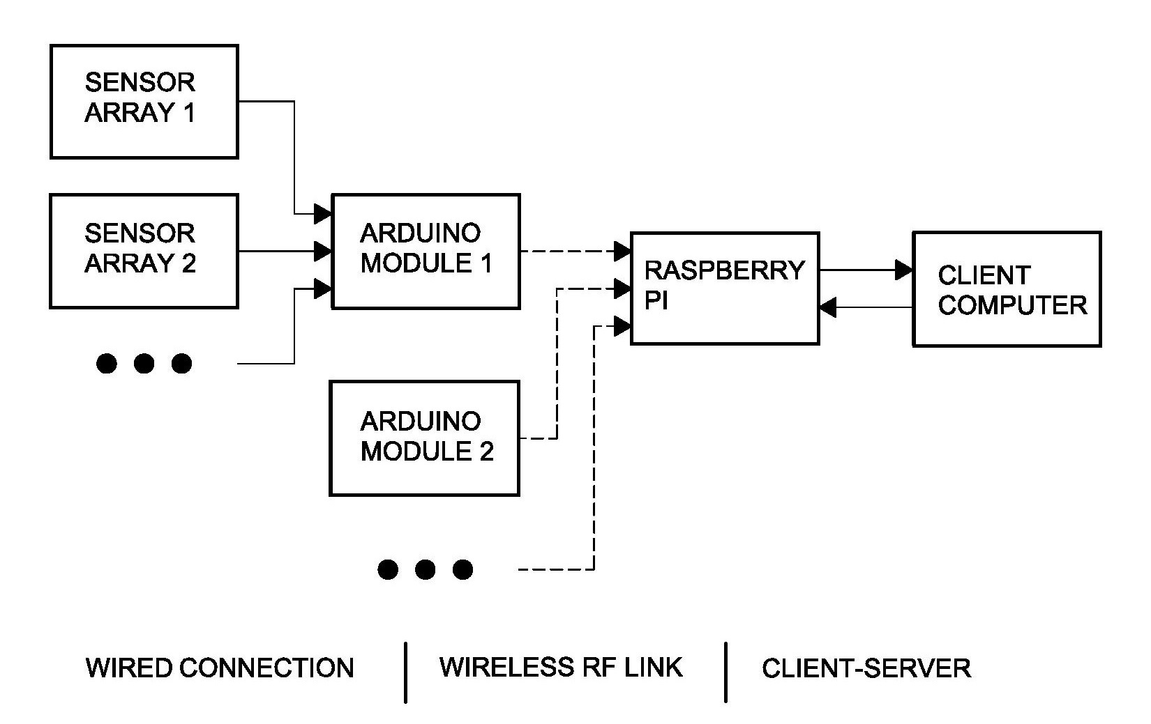

System cost:

Price is depended on the scope of application. With wide sensor network, and addition of remotely located modules, the cost of the system will increase. However, cost of the central unit (Raspberry Pi) is fixed, thus system expansion does not represent financial burden. Additionally, radio frequency link is inexpensive, since RF modules can be found under 2 CAD.

Development plan:

Development of the system can start immediately and be part of senior project design for the upcoming college year. Work load can be divided into two main sections:

* Low-level hardware interfacing and Arduino programming
* Operating system programming and Networking

Project development can be done in collaboration with fellow student in EETG program - Benjamin Sabean. Benjamin has a degree in Computer Science and experience with Raspberry Pi, Linux, Networking and more.

Documents provided upon completion:

* Full hardware description
* Guide for adding, changing type and removing sensors
* Full software description

Milestone reports and any additional documents will be provided.

Thank you for your consideration.